 Microsoft Power Apps and SAP with Azure

# Set Up and Prerequisites

Contents

*Lab Overview and Pre-requisites ................................................................................................................................................................................1*

Set Up and Prerequisites 1

Task 1: Set up a tenant 2

Task 2: Obtain a Power Apps Trial 2

Optional- Turn off Multi-factor authentication 2

Task 3: Create a trial environment 2

Terms of Use 2

## Lab Overview and Pre-requisites

The estimated time to complete this setup is 30 minutes.

Creating your tenant ahead of time will maximize the time available for learning on the day, and allow you to get started with Power Platform quickly and easily.

## Set Up and Prerequisites

|  |  |
| --- | --- |
| This document takes you through setting up a tenant to use for training.  You will:   * Create a trial account and set up a tenant * Create a new environment | The time to complete this setup is [30] minutes. |

# Task 1: Set up a tenant

You will sign up for an Office 365 E3 tenant with trial licenses for Power Virtual Agents and Power Apps to perform the labs.

Follow the instructions below to sign up for a free trial.

Open a private browser

➔ If you’re in Edge, open a New InPrivate Window.

I. To open a New InPrivate Window in Edge: click  II. Then, select New InPrivate Window.

If you’re in Chrome, open a New Incognito Window.

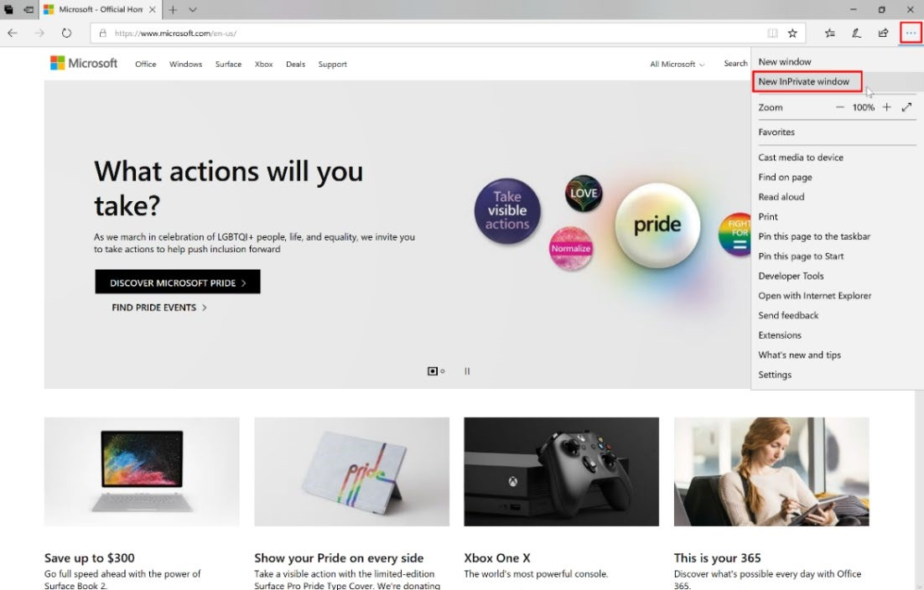

I. To open New Incognito Window in Chrome: click 

II.

Then, select New Incognito Window.

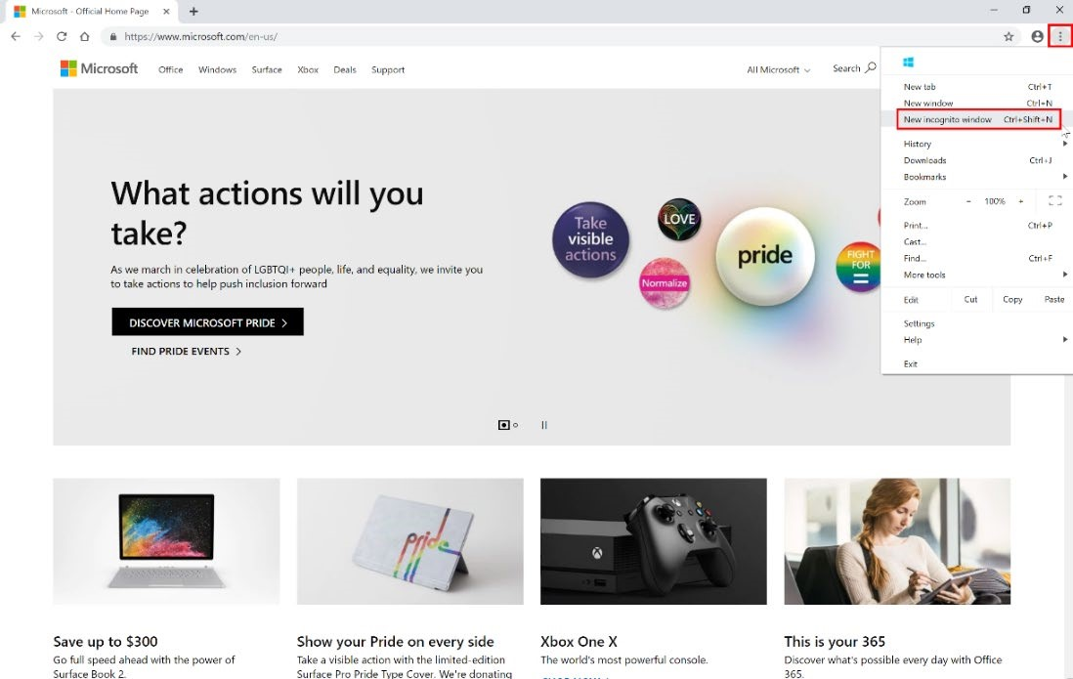

1. After opening an **in-private browser,** navigate to<https://aka.ms/appinadayo365signup>

1. Enter a personal e-mail address and click **Next**.

1. Click **Set up account**.

1. Fill in your information and click **Next.**

1. You’ll be asked to verify you identify using either phone call or text message. Follow directions and confirm your identity by specifying phone number.

1. Create a username, Domain name, and password **Note:** *if your domain name is not unique modify before continuing.*
2. Click **Next** if the custom domain name is available.

1. Wait while tenant is created. It usually takes less than 1 min.

1. Click **Get started**. This will navigate you to **Office admin portal**. When you land on the admin center page, you need to **EXIT SETUP**.

# Task 2: Obtain a Power Apps Trial

1. Navigate to [https://www.portal.office.com](https://www.portal.office.com/) and click on **Admin** to open the Admin Center.

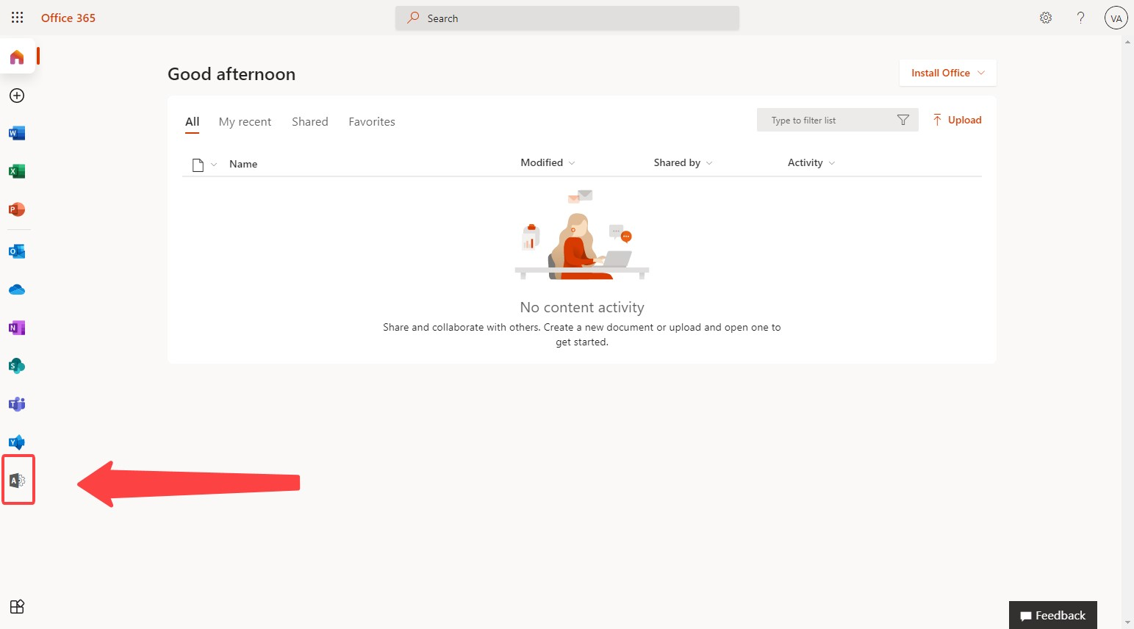

1. On the left side of the Admin Center, expand **Billing** and click on **Purchase Services**.

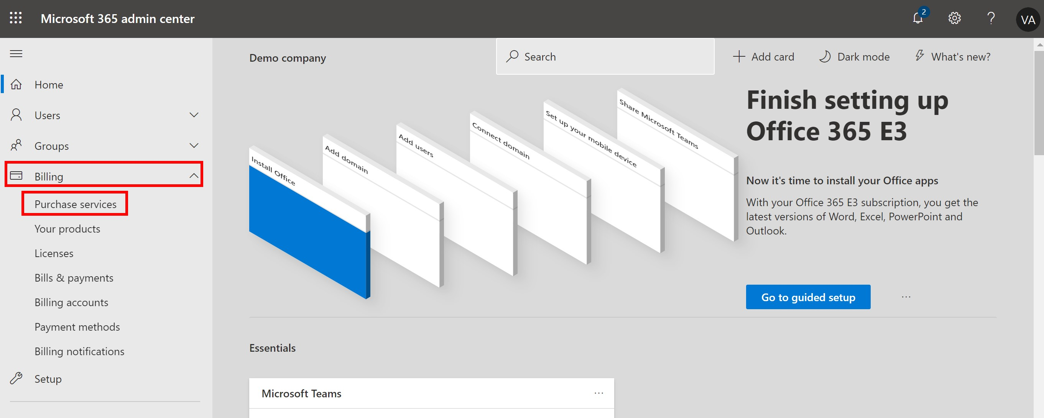

1. Search for **Power Apps**.

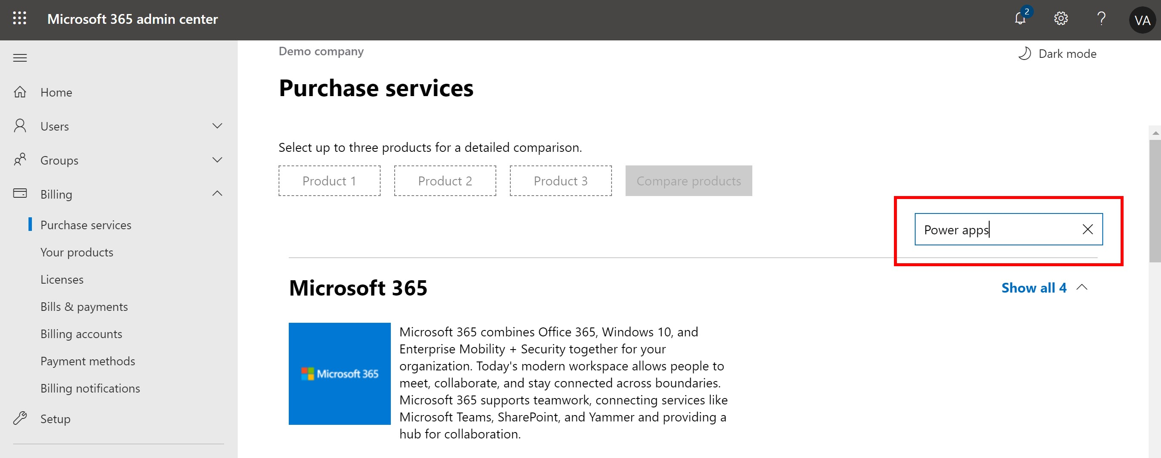

1. Find **Power Apps per user plan** and click on **Details**. Ensure this is **per user plan**, do not select per app plan.

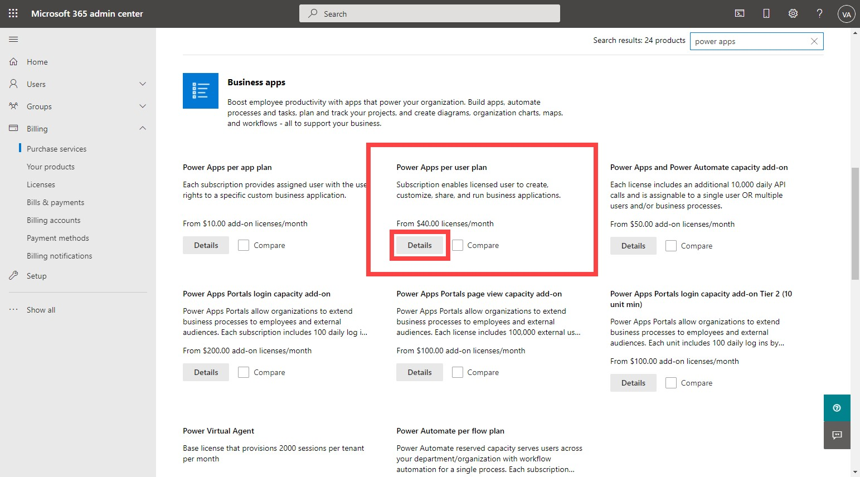

1. Click on **Start free trial** for Power Apps per user plan.

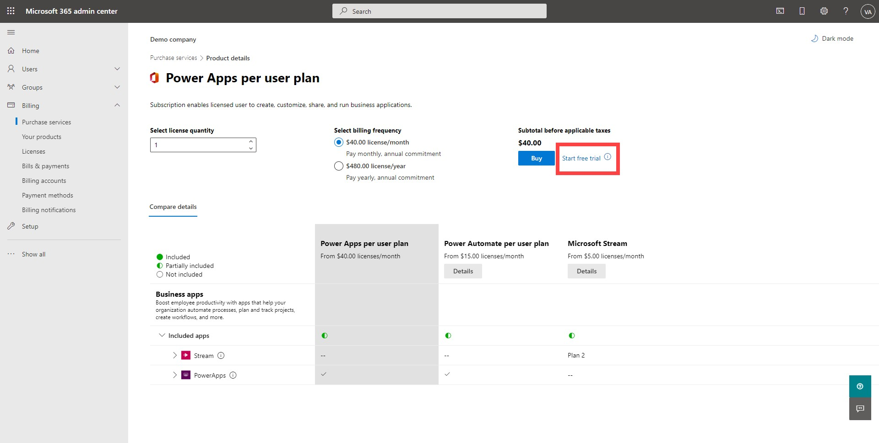

1. Click **Try now** to confirm your order.

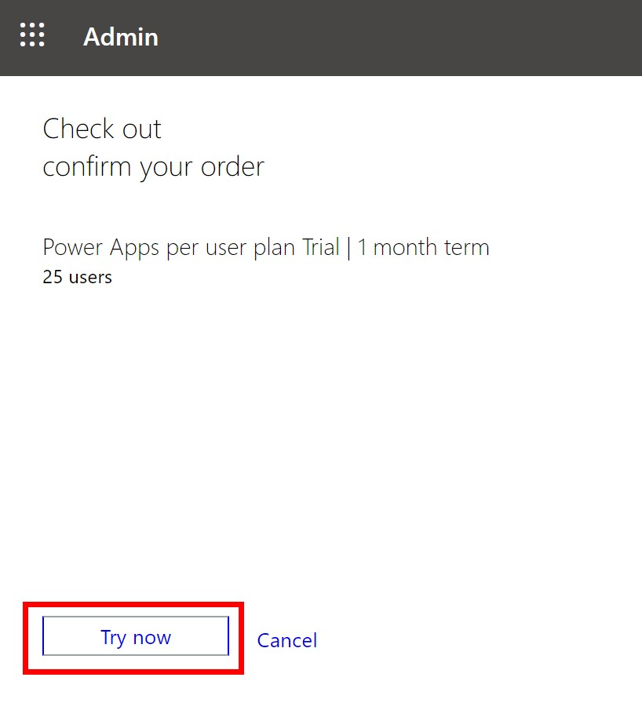

7.

Click

**Continue**

on your order receipt screen.

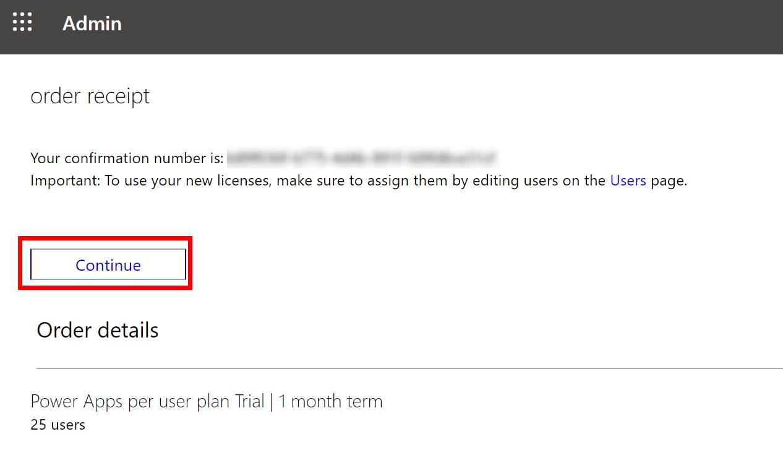

# Optional- Turn off Multi-factor authentication

Upon login, users may be asked to set up multi-factor authentication (MFA) on their trial account. To avoid this, you can turn MFA off for the tenant via the Azure portal.

1. Navigate to <https://portal.azure.com/>and sign in with your admin account for the tenant.

2.

Click on the

icon on the top left of the screen to expand the navigation menu.

3.

Click on

**Azure Active Directory**

.

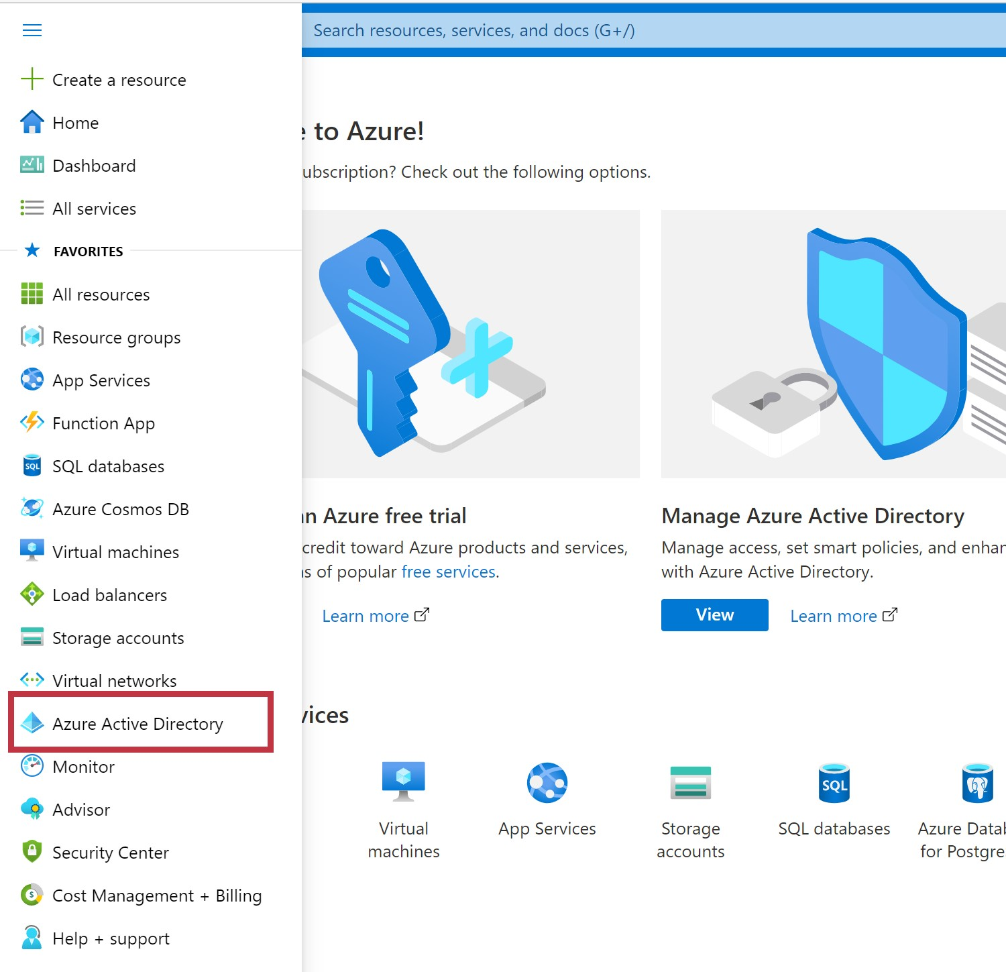

1. Click on **Properties** then **Manage Security defaults**.

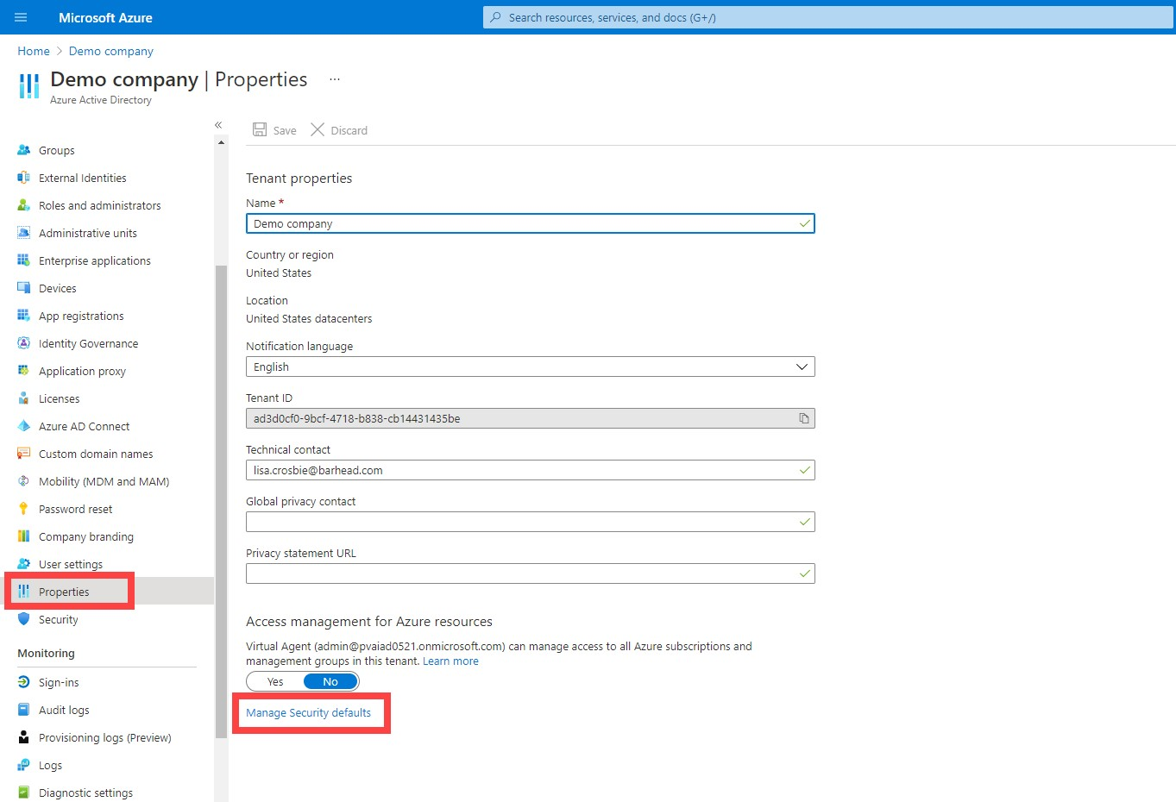

1. Switch the Enable Security defaults toggle to **No**. Then, **save** your changes.

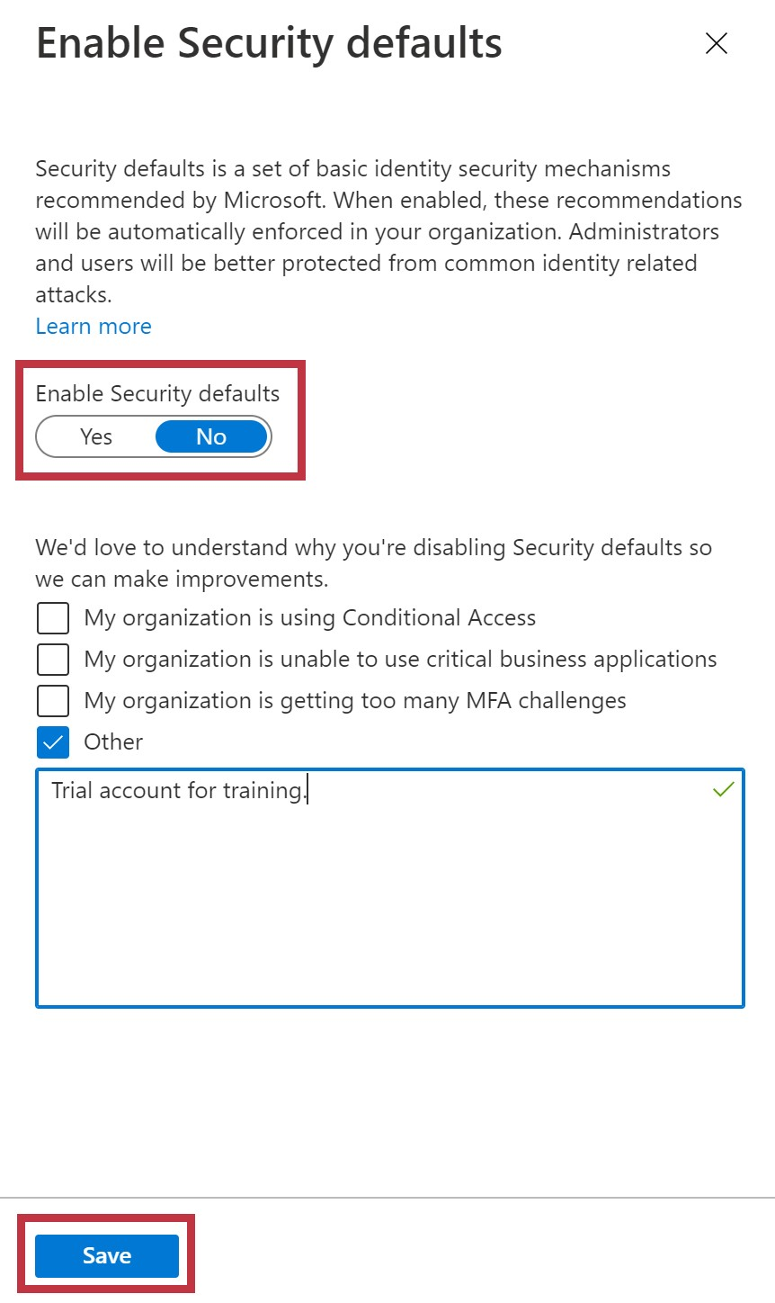

# Task 3: Create a trial environment

You’ll need create a Power Apps trial environment to store the Canvas Power App you will be creating.

1. In your private browser, navigate to the Power Platform Admin Center

[/https://admin.powerplatform.microsoft.com/environment](https://admin.powerplatform.microsoft.com/environments)[s,](https://admin.powerapps.com/) and sign in with the trial account you just created.

1. Select +New to create a new Environment.

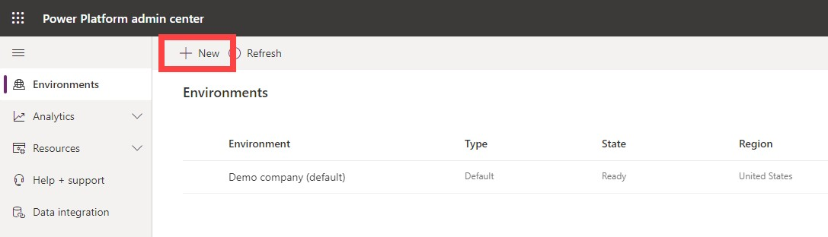

Fill in the fields in the New environment dialog box with these values and select **Next** to continue. *Note: Creating an environment may take up to one minute.*

* + Environment Name: Contoso Test
  + Type: Trial
  + Region: United States (default)
  + Create a database for this environment? Yes

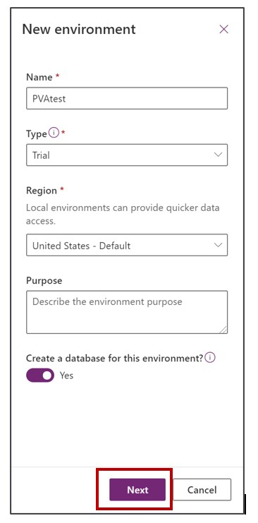

1. Specify values in the **Add database** dialog box, as follows:.
   * Language: English
   * URL:(*leave this blank)*
   * Currency: USD
   * Select the “Deploy Sample Apps and Data” option
   * Click Save

1. An alert bar will pop up to tell you that your new environment is getting prepared.

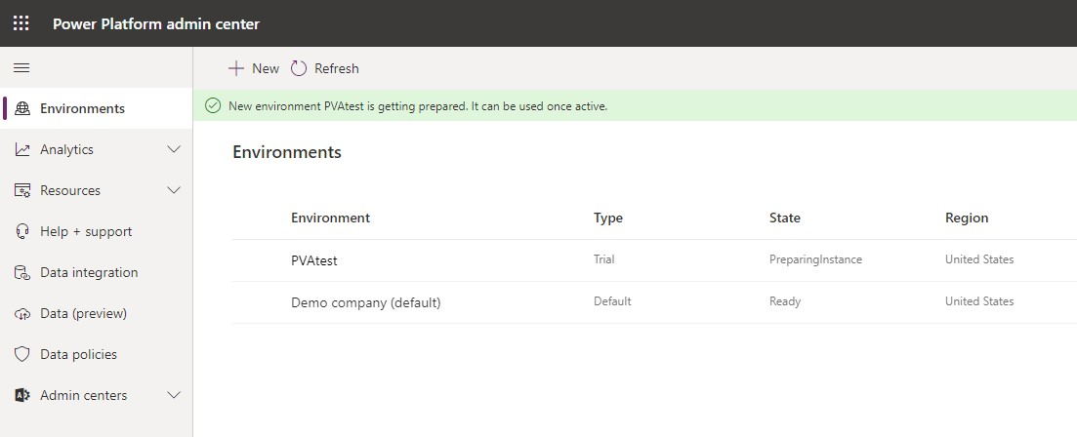

1. Wait about a minute and click refresh. When your environment is fully prepared, you will see this message.

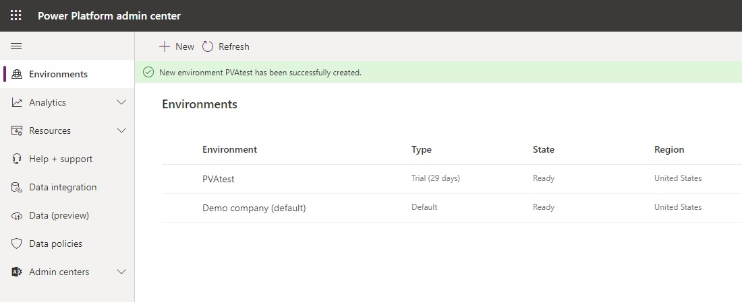

1. Congratulations! You are all set for the training!

# Terms of Use

By using this document, in whole or in part, you agree to the following terms:

### Notice

Information and views expressed in this document, including (without limitation) URL and other Internet Web site references, may change without notice. Examples depicted herein, if any, are provided for illustration only and are fictitious. No real association or connection is intended or should be inferred. This document does not provide you with any legal rights to any intellectual property in any Microsoft product.

### Use Limitations

Copying or reproduction, in whole or in part, of this document to any other server or location for further reproduction or redistribution is expressly prohibited. Microsoft provides you with this document for purposes of obtaining your suggestions, comments, input, ideas, or know-how, in any form, ("Feedback") and to provide you with a learning experience. You may use this document only to evaluate its content and provide feedback to Microsoft. You may not use this document for any other purpose. You may not modify, copy, distribute, transmit, display, perform, reproduce, publish, license, create derivative works from, transfer, or sell this document or any portion thereof. You may copy and use this document for your internal, reference purposes only.

### Feedback

If you give Microsoft any Feedback about this document or the subject matter herein (including, without limitation, any technology, features, functionality, and/or concepts), you give to Microsoft, without charge, the right to use, share, and freely commercialize Feedback in any way and for any purpose. You also give third parties, without charge, the right to use, or interface with, any Microsoft products or services that include the Feedback. You represent and warrant that you own or otherwise control all rights to such Feedback and that no such Feedback is subject to any third-party rights.

### DISCLAIMERS

CERTAIN SOFTWARE, TECHNOLOGY, PRODUCTS, FEATURES, AND FUNCTIONALITY (COLLECTIVELY "CONCEPTS"),

INCLUDING POTENTIAL NEW CONCEPTS, REFERENCED IN THIS DOCUMENT ARE IN A SIMULATED ENVIRONMENT

WITHOUT COMPLEX SET-UP OR INSTALLATION AND ARE INTENDED FOR FEEDBACK AND TRAINING PURPOSES

ONLY. THE CONCEPTS REPRESENTED IN THIS DOCUMENT MAY NOT REPRESENT FULL FEATURE CONCEPTS AND MAY

NOT WORK THE WAY A FINAL VERSION MAY WORK. MICROSOFT ALSO MAY NOT RELEASE A FINAL VERSION OF SUCH

CONCEPTS. YOUR EXPERIENCE WITH USING SUCH CONCEPTS IN A PHYSICAL ENVIRONMENT MAY ALSO BE DIFFERENT.

THIS DOCUMENT, AND THE CONCEPTS AND TRAINING PROVIDED HEREIN, IS PROVIDED “AS IS”, WITHOUT WARRANTY

OF ANY KIND, WHETHER EXPRESS, IMPLIED, OR STATUTORY, INCLUDING (WITHOUT LIMITATION) THE WARRANTIES OF

MERCHANTABILITY, FITNESS FOR A PARTICULAR PURPOSE, TITLE, AND NONINFRINGEMENT. MICROSOFT DOES NOT

MAKE ANY ASSURANCES OR REPRESENTATIONS WITH REGARD TO THE ACCURACY OF THE RESULTS, THE OUTPUT THAT DERIVES FROM USE OF THIS DOCUMENT OR THE CONCEPTS, OR THE SUITABILITY OF THE CONCEPTS OR INFORMATION CONTAINED IN THIS DOCUMENT FOR ANY PURPOSE.

MICROSOFT POWER VIRTUAL AGENTS (1) IS NOT INTENDED OR MADE AVAILABLE AS A MEDICAL DEVICE FOR THE

DIAGNOSIS OF DISEASE OR OTHER CONDITIONS, OR IN THE CURE, MITIGATION, TREATMENT OR PREVENTION OF

DISEASE, OR OTHERWISE TO BE USED AS A COMPONENT OF ANY CLINICAL OFFERING OR PRODUCT, AND NO LICENSE

OR RIGHT IS GRANTED TO USE MICROSOFT POWER VIRTUAL AGENTS FOR SUCH PURPOSES, (2) IS NOT DESIGNED OR

INTENDED TO BE A SUBSTITUTE FOR PROFESSIONAL MEDICAL ADVICE, DIAGNOSIS, TREATMENT, OR JUDGMENT AND SHOULD NOT BE USED AS A SUBSTITUTE FOR, OR TO REPLACE, PROFESSIONAL MEDICAL ADVICE, DIAGNOSIS,

TREATMENT, OR JUDGMENT, AND (3) SHOULD NOT BE USED FOR EMERGENCIES AND DOES NOT SUPPORT EMERGENCY

CALLS. ANY CHATBOT YOU CREATE USING MICROSOFT POWER VIRTUAL AGENTS IS YOUR OWN PRODUCT OR SERVICE,

SEPARATE AND APART FROM MICROSOFT POWER VIRTUAL AGENTS. YOU ARE SOLELY RESPONSIBLE FOR THE DESIGN,

DEVELOPMENT, AND IMPLEMENTATION OF YOUR CHATBOT (INCLUDING INCORPORATION OF IT INTO ANY PRODUCT

OR SERVICE INTENDED FOR MEDICAL OR CLINICAL USE) AND FOR EXPLICITLY PROVIDING END USERS WITH

APPROPRIATE WARNINGS AND DISCLAIMERS PERTAINING TO USE OF YOUR CHATBOT. YOU ARE SOLELY RESPONSIBLE

FOR ANY PERSONAL INJURY OR DEATH THAT MAY OCCUR AS A RESULT OF YOUR CHATBOT OR YOUR USE OF

MICROSOFT POWER VIRTUAL AGENTS IN CONNECTION WITH YOUR CHATBOT, INCLUDING (WITHOUT LIMITATION) ANY SUCH INJURIES TO END USERS.